Chapter-1

INFORMATION SYSTEM

INFORMATION

Information can be defined as the data which is organized and presented at a time and place so that the decision maker may take necessary action. Information in other words is the result/product of processing data.

SYSTEM

A system is composed with set of interrelated components which

has a clearly defined boundary and working together to achieve a

common set of objectives by accepting inputs and producing

outputs in an organized transformation process.

1. INTRODUCTION OF INFORMATION SYSTEM

✓ Combination OR arrangement of six key elements:
People

Hardware

Software
IS
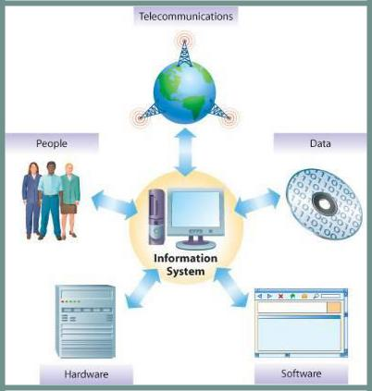

Fig 1.1 Component of IS

Telecommunications networks

Processes

- A set of interrelated components that collect (or retrieve), process, store, and distribute information to

Support decision making and control in an organization

- Information Technology falls under the information system, Information technology deals with technology

involved in the system.

1 Compiled By:-Shraddha Bikash Upadhyay ,Asst.Prof,NEC

Chapter-1

SOURCES OF IS

Data – raw, unformatted information E.g.: 5433333353

Information – data that is transformed to have a meaning E.g.: (543) 333-3353

Knowledge – body of governing procedures used to organize or manipulate data

Wisdom – accumulated knowledge

1.1 EVOLUTION OF IS

- Electronic Data Processing (EDP) /Transaction Processing System 1960s

Until the 1960s, the role of most information systems was

simple.
IS

Application that capture and process data about business transaction, it is a process to reduce and improve value added to the business.

Purposes such as transactions processing, record-keeping, accounting, recording, classifying, manipulating, maintaining, and summarizing data.

These process data resulting from business transactions, update operational databases, and produce business documents. Examples: sales and inventory processing and

accounting systems.

✓ Management Information Systems (MIS) 1960s
Another role was added to the use of computers: the processing of data into useful informative reports. The concept of management information systems (MIS) was born which provides management oriented reporting.

This new role focused on developing business applications that provided managerial end users with predefined

2 Compiled By:-Shraddha Bikash Upadhyay ,Asst.Prof,NEC

Chapter-1

management reports that that would give managers the information they needed for decision-making purposes.

Examples: sales analysis, production performance and cost trend reporting systems.

✓ Decision support systems (DSS) 1970s
By the 1970s, these pre-defined management reports were not sufficient to meet many of the decision-making needs of management.

In order to satisfy such needs, the concept of decision support systems (DSS) was born. The new role for information systems was to provide managerial end users with ad hoc and interactive support of their d cision-making processes.

Decision support systems – provide interactive ad hoc support for the decision-making processes of managers and other business professionals.
IS

Examples: product pricing, profitability forecasting and risk analysis systems.

- Executive_{Science,NEC}InformationSystem 1980s

In the 1980s, the introduction of microcomputers into the workpla ushered in a new era, which led to a profound effect on organizations.
The rapid development of microcomputer processing power

(e.g. Intel’s Pentium microprocessor), application software packages (e.g. Microsoft Office), and telecommunication networks gave birth to the phenomenon of end user computing.

End users could now use their own computing resources to support their job requirements instead of waiting for the indirect support of a centralized corporate information services department.

It became evident that most top executives did not directly use either the MIS reports

3 Compiled By:-Shraddha Bikash Upadhyay ,Asst.Prof,NEC

Chapter-1

Or the analytical modelling capabilities of DSS, so the concept of executive information systems (EIS) was developed.

Provide critical information from MIS, DSS and other sources, tailored to the information needs of executives. Examples: systems for easy access to analysis of business performance, actions of all competitors, and economic developments to support strategic planning.

Moreover, breakthroughs occurred in the development and application of artificial intelligence (AI) techniques to business information systems. With less need for human intervention, knowledge workers could be fr d up to handle more complex tasks. Expert syste s (ES) and other knowledge management systems (KMS) also forged a new role for information systems. ES can serve as consultants to users by providing expert advice in limited subject areas.
IS

Expert systems – knowledge-based systems that provide expert advice and act as expert consultants to users. Examples: credit application advisor, process monitor, and diagnostic maintenance systems.

A computer application that performs a task that would otherwise be performed by a human expert. For example, the e are expert systems that can diagnose human illnesses, make financial forecasts, and schedule routes for delivery vehicles. Some expert systems are designed to take the place of human experts, while others are designed to aid them.

Knowledge management systems – knowledge-based systems that support the creation, organization and dissemination of business knowledge within the enterprise. Examples: intranet access to best business practices, sales proposal strategies and customer problem resolution systems.

4 Compiled By:-Shraddha Bikash Upadhyay ,Asst.Prof,NEC

Chapter-1

✓ Enterprise Resource Planning Mid-1990s

The mid- to late 1990s saw the revolutionary emergence of (ERP) systems.

This organization-specific form of a strategic information system integrates all facts of a firm, including its planning, manufacturing, sales, resource management, customer relations, inventory control, order tracking, financial management, human resources and marketing – virtually every business function.

The primary advantage of these ERP systems lies in their common interface for all computer-based organiza ional functions and their tight integration and data sharing needed for flexible strategic decision making.
✓ Data warehouse (DW)

A data warehouse stores data that have been extracted from the various operational, external and other databases of an organization. It is a central source of the data that have been cleaned, transformed and catalogued so they can be used by
IS

managers and other business professionals for data mining,

✓ Data mining (DM)
Analyzes the vast amounts of historical that have been prepared for analysis data warehouses

Online analytical processing (OLAP)
online analytical processing and other forms of business analysis,_{✓Science,NE}marketresearchand_{C}decision support.

Online analytical processing enables managers and analysts to interactively examine and manipulate large amounts of detailed and consolidated data from many perspectives. OLAP involves analyzing complex relationships among thousands or even millions of data items stored in data marts, DW and other multi-dimensional databases to discover patterns, trends and exceptional conditions. An OLAP session takes place online in real time, with rapid responses to a manager’s or analyst’s queries, so that their analytical or decision-making process is undisturbed.

✓ Mobile Computing

5

Chapter-1

Information systems that support employees who are working with customers or business partners outside the physical boundaries of their company; can be done over wire or wireless networks.

1.1 CLASSIFICATION OF IS

Information Systems may be broadly classified as Operations

support systems and

Management Support Systems.

- Operations support systems: process data generated by business operations

Major categories are:

i) Transaction processing Systems (TPS) ii) Office Automation (OA)

- Management Support Systems: provide information and support needed for

Effective decision making by managers Major categories are

i) Management Information System (MIS) ii) Decision Support Systems (DSS)

iii) Executive Information System (ESS)
IS
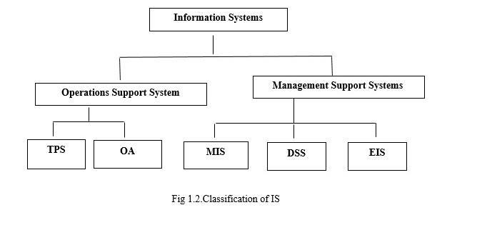

Office Automation

Supports wide range of business office activities that provide the improved workflow and communication between workers, regardless of whether or not these workers are located in same office.

Personal IS is designed to meet the needs of single users to boost the individual productivity

Office automation refers to the varied computer machinery and software used to digitally create, collect, store,

6

Chapter-1

manipulate, and relay office information needed for accomplishing basic tasks.

1.2 IS IN FUNCTIONAL AREA

Supports a functional area by increasing its internal

effectiveness and efficiency. Typically found for:

Finance (FIN): provide internal and external professional access to stock, investment and capital spending information.

Accounting (ACC): similar to financial MIS, more related to invoicing, payroll, receivables.

Marketing (MKT): pricing, distribution, promotional, and information by customer and salesperson.

Operations (OPS): regular reports on production, yield, quality, inventory levels. T ese systems typically deal with manufacturing, sourcing, and supply chain management.
IS

Human Resources Management (HR): employees, benefits, hiring, etc.

1.3 INFORMATION SYST M ARCHITECTURE

Provides a framework into which various people with different perspectives can organize and view fundamental building blocks of information system.

Need to improve performance.

Need to improve information.

Need to improve economics, control cost and profits.

Need to improve control or security.

Need to improve efficiency of people and process.

7

Chapter-1

To improve services to customers, suppliers, partners, employees.
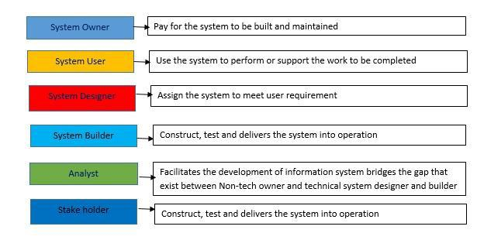

Fig 1.3 Information System

- QUALITIES OF INFORMATION SYSTEMS

  - Relevance

Information should be relevant to strategic decision that company management is currently reviewing. Because companies may review everal business opportunities At one time, avoiding information not relating to the decision is essential.
IS

✓ Accuracy
Information system should be accurate and avoid any timely

✓ Timely
making_{Science,NEC}decisionbasedonestimates can lead to cost overruns or lower profits from futur operations.
Many decisions are based on information from certain

pe iods, such as quarterly or annual periods.

Information outside of the requested time frame may skew information and lead to improper informed decision.
- Exhaustive

Information gathering at early state is exhaustive, including all types of company information
- Cost-Effective

Information system need to be cost effective and efficient system for gathering information. Most of these systems are developed internally, creating cost that cannot be passed to client.
- Available:

8

Chapter-1

Information may be useless if it is not readily accessible sin the desired form, when it is needed. Advances in technology have made information more accessible today than ever before.

✓ Reliable:
The information should be counted on to be trustworthy. It should be accurate, consistent with facts and verifiable. Inadequate or incorrect information generally leads to decisions of poor quality. For example, sales figures that have not been adjusted for returns and refunds are not reliable.
- Concise:

Too much information is a big burden on management and cannot be processed in time and accurately due to “bounded rationality”. Bounded rationality determines the limits of the thinking process which cannot sort out and process large amounts of information. Accordingly, information should be to the point and just enough – no more, no less.
IS

1.5 MANAGING INFORMATION SYSTEM RESOURCES

Which IT Resources are Managed and By Whom?

- During the early 1950s, Information Systems Department (ISD) managed ALL of the only omputing resource, the mainframe.

- Today, computing resources are located through the organization and almost all employees use computers in their work.

- This system is known as end user computing.

- The Role of the IS Department

- The ISD is responsible for corporate-level and shared resources and for using IT to solve end users’ business problems.

- End users are responsible for their own computing resources and departmental resources.

- ISD and end users work together as partners to manage the IT resources.

9

Chapter-1

MANAGEMENT INFORMATION SYSTEM (MIS)

MIS Provides information that organizations need to manage themselves efficiently and effectively.

MIS manages
- Hardware

- Software

- Data(Information for Decision Making)

- Procedure(Design ,Development and Documentation)

- People, Individual groups or Organization

MIS is different from IS, in that they are used to analyses and facilitate strategy and operational activities_{Ghimire,Dept}..MISisusedtofer to study of how individuals groups and organization evaluates ,design

,implement manage and utilize systems to generate information improve efficiently and effectiveness of decision making ,including system termed decision support systems, expert system and executive information system.

MIS includes
✓ Decision Support System.
IS

- Resource Management

- HRM (Human Resource Management)

- Enterprise Resource Planning.

- Supply Chain Management

- Customer Relationship Management.

- Project Management and Database management

1.6. BALANCED SCORECARD – CASE STUDIES

The balanced scorecard is a strategic planning and management system that is used extensively in business and industry, government, and nonprofit organizations worldwide to align business activities to the vision and strategy of the organization, improve internal and external communications, and monitor organization performance against strategic goals.
- When you can’t measure, you can’t manage.

- Scorecard is about making your performance measureable.

10

Chapter-1

- You need to consider all perspectives of measurements. So that you get a complete analysis. So you need it to be

Balance Scorecard (BSC).

It is known as strategy map for

  - Mercantile

    - Better Product

    - Research for current needs

    - Customer Satisfaction

    - Profit

  - Community Health

    - Collection of Funds

    - Proper Training for staffs

    - Proper Mobilization plans

      - Better Public Health.

ADVANTAGES OF BALANCESCORECARD (BSC)

- BETTER STRATEGIC PLANNING

  - BSC provides powerful framework for building and communicating strategy
IS

  - The business model is visualized in a strategy Map which forces managers to think about cause and

effect relationship.

  - The process of creating a strategy map ensures that conse sus is reached over set of interrelated

strategic objectives.

- IMPROVED STRATEGIC COMMUNICATION AND

EXECUTION

  - The fact that the strategy with all its interrelated objectives is mapped on one piece of paper allows

companies to easily communicate strategy internally and externally.

  - This plan on a page facilitates the understanding of the strategy and helps to engage

Staff and external stakeholder in the delivery and review of strategy.

11

Chapter-1

  - It is impossible to execute a strategy that is not understood by everybody.

- BETTER MANAGEMENT INFORMATION

  - Balanced scorecard approach forces organization to design key performance indicators for their various

strategic objectives.

  - This ensures that companies are measuring what actually matters.

  - Research shows that companies with BSC approach tend to report higher quality management

information and gain increasing benefits from the way this information is used to guide management &decision making.

- IMPROVED PERFORMANCE REPORTING

  - Increasing needs and requirements for transparency can be me if companies create meaningful
IS

management reports and dashboards to

communicate performance both internally and

Science,NEC^{xternally.}

5. BETTER STRATEGIC ALIGNMENT

✓ In order to execute a plan well organization need to ensure that all business and support units are working towards the same goals.

12

Chapter-1 |  | IS
PERSPECTIVES IN BALANCED SCORECARD | IMPLEMENTING BSC IN IT ENVIRONMENT
 | a) | Financial Contribution
 |  | Mission
 |  | To obtain a measurable financial contribution
 |  | from investment in IT portfolio.
 |  | Obje tives
 |  | • To reduce IT department expenses,
 |  | • Sell IT product/Service to third parties
 |  | • Maximize business values of new and
 |  | existing IT Projects.
 |  | • Maximize business value of overall IT
 |  | infrastructure.
Fig 1.4 Perspective in Balance Scorecard | b) | Customer Focus
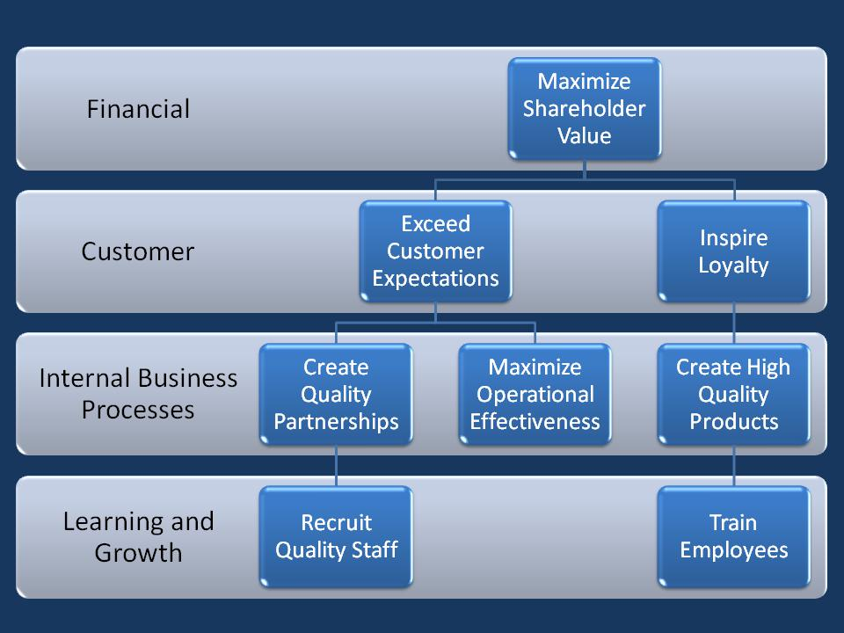
Mission
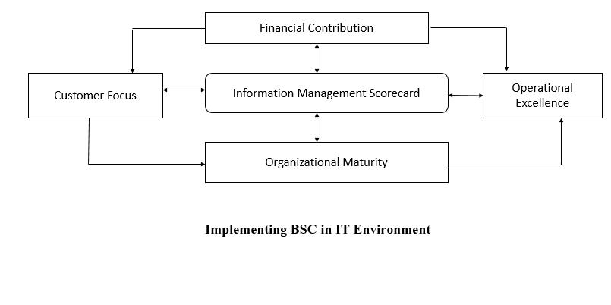
To be preferred supplier of information systems that help customers maximize business opportunities through IT.

Objectives

• Become Preferred Supplier of IT applications

• Become Preferred Service provider of IT applications

Fig 1.5 Implementing BSC in IT Environment

13

Chapter-1

  - Build reliable partnership with IT Customers/users

  - Ensure Customer/user Satisfaction with IT service received

- Operational Excellence
Mission

To deliver high-quality information product/services with efficiency Objectives

Establish quality software development process

- Organizational Maturity
Mission

To develop Opportunities

To position IT to answer future challenges Objectives

Identify and ensure growth in strategic IT technology/skills

Build expertise of IT personnel with regular training and education program
Improve employee satisfaction and productivity
IS

IMPLEMENTING INFORMATION MANAGEMENT
SCORECARD
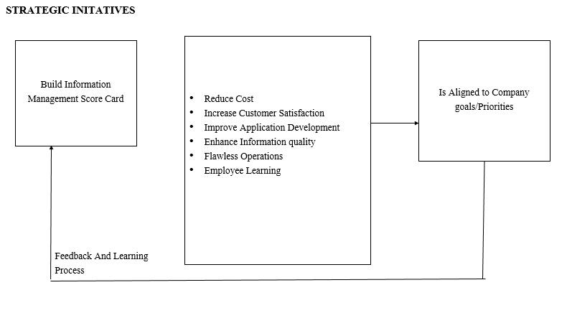

Fig 1.6 Implementing Information system Scorecard

14

Chapter-1

CASE STUDY 1

- Executive Balanced scorecard is implemented in United Nations Agency.

- Performance Management Tool for Regional Balanced Scorecard to monitor and drive Regional Management Priorities.

- After 12 months pilot, BSC reflect evolving strategic goals and Priorities

CASE STUDY 2

A Balanced Scorecard initiative represents a watershed event in an organization’s evolution. It is a challenging, inter-disciplinary process of cultural change. To be successful, an organization needs a defined, multi-faceted approach that embraces educati n, communication, scorecard development, and ongoing implementation. The Microsoft Balanced Scorecard Fram work meets these criteria.

The Microsoft approach to Balanced Scorecard automation brings together:

- Portal technology to facilitate education, change, and communication.

- Information on best practices from Balanced Scorecard experts.
IS

- Strategy and metric management in conformance with the specifications put forth by the Balanced Scorecard Collaborative, the consulting organization founded by the creators of the Balanced Scorecard.

- Analytic capabilities to bridge the gap between problem identification, as shown by out-of-tolerance measures, and analysis, to determine underlying opportunities for performance enhancement.

- Actionable and operational tools to enhance and work in conjunction with business intelligence tools.

Knowledge management to permit sharing and control of documents, on-line collaboration, work flow, and document searching
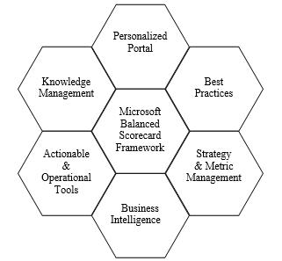

15

Chapter-1 IS

CASE STUDY 3
Relation between KPI and BSC Relation

KPIs (Key Performance Indicators) relate to the tools used by the organization to measure its performance, while BSC (Balanced Scorecard) depends mainly on four perspectives; financial, customers, internal processes, and learning and growth perspectives.

BSC Software
Step 1: Financial Contribution

Determine the overall business value of IT department after weighing the overall cost of IT project against benefits it will deliver Step 2: Customer Focus

Consider the impact of IT projects on the customers of information Step 3: Operational Excellence

Define the core internal process of IT department that determine operational excellence.

Step 4: Organization Maturity

Determine whether the organization promotes learning and growth among employees to meet future technology challenges.

16

